Вопросы к экзамену Система искусственного интеллекта
- Define different fields that the Artificial intelligence covers. Describe main tasks of the Artificial intelligence.
- Describe the gradient descent. Characterize a meaning of the length of the step (learning rate) and a number of iterations.
- Create a program in Visual Prolog. The database contains the following facts:
likes ("Anna," apples).
likes ("Sergey", bananas).
likes ("Andrey", apples).
likes ("Sveta", chocolate).
likes ("Vova", chocolate).
likes ("Anna", chocolate).
loves ("Sveta", oranges).
likes ("Vova", bananas).
Make a program that defines:
a) everyone who loves bananas;
b) who likes both chocolate and apples;
c) what Vova likes;
d) that they love both Sveta and Vova.

- Define different fields that the Artificial intelligence covers. Write about natural language processing and knowledge representation.
- Describe the gradient descent. Characterize what happens when a very small or very big learning rate is chosen.
- Create a program in Visual Prolog. The database contains the following facts:
plays ("Sasha", football).
plays ("Katya", tennis).
plays ("Sasha", tennis).
plays ("Andrew", football).
plays ("Oleg", football).
plays ("Olga", tennis).
plays ("Katya", volleyball).
plays ("Oleg", volleyball).
Make a program that defines:
a) what kind of sport is Andrey interested in;
b) everyone who plays volleyball;
c) what kind of sport are Olga and Sasha interested in;
d) who is fond of football and volleyball.
- Define different fields that the Artificial intelligence covers. Write about automated reasoning, machine learning and robotics.
- Write about regression. Describe the linear regression and the least squares cost function for linear regression.
- Create a program in Visual Prolog. The database contains the following facts:
fondOf ("Kolya", “guitar”).
fondOf ("Olya", “violin”).
fondOf ("Dima", “swimming”).
fondOf ("Tanya", “tennis”).
sport (“swimming”).
sport (“tennis”).
music_inst (“violin”).
music_inst (“guitar”).
a.) Make up the athlete's rule and determine who is keen on sports;
b.) Make up a musician rule and determine who is fond of music;

- Intelligent agents. Describe the approach of the rational agent. Give examples of rational and irrational situations.
- Write about linear regression. Describe the learning process with the use of the gradient descent and how a new value is predicted.
- Create a program in Visual Prolog. The database contains the following facts
builds (“Gim”, “lumber_mill”).
builds (“Sylvanas”, “smithy”).
builds (“Ankeron”, “tower”).
builds (“Druko”, “workshop”).
builds (“Garrosh”, “fortress”).
builds (“Cronosh”, “tower”).
builds (“Alleria”, “smithy”).
team1 (“Gim”).
team1 (“Druko”).
team1 (“Cronosh”).
team2 (“Garrosh”).
team2 (“Alleria”).
team2 (“Sylvanas”).
team2 (“Ankeron”).
Make a program that defines:
a) who builds the workshop;
b) everyone who builds the tower;
c) anyone who is in a team 1;
d) create a new rule build_team(X)and identify anyone who builds the smithy and in a team 2
- Intelligent agents. Describe performance, environment, actuators and sensors of agents.
- Write about classification. Describe a hyperplane that divides a feature space into two classes.
- Write down the sequence of numbers using the Breadth-first and Depth-first search in the binary tree
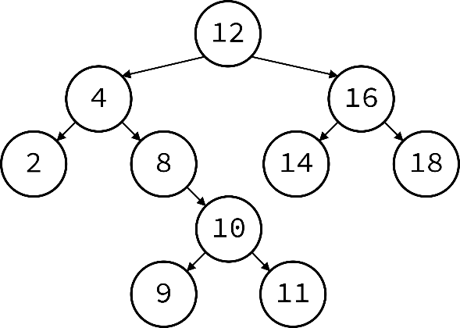
- Intelligent agents. Write about the structure of agents and agent programs
- Write about classification. Describe a linear classifier
- Write down the sequence of numbers using the Breadth-first and Depth-first search in the binary tree
- Intelligent agents. Describe how an agent interacts with the environments. You need to focus on sensors and actuators
- Write about classification. Describe the difference between binary and multiclass classification
Create a program in Visual Prolog. The database contains the following facts
research (“Gally”, “space”).
research (“Gnilias”, “medicine”).
research (“Odin”, “armory”).
research (“Dave”, “nuclear_weapon”).
research (“Chen”, “cookery”).
research (“Rango”, “medicine”).
research (“Varimatras”, “space”).
squad1 (“Gnilias”).
squad1 (“Odin”).
squad1 (“Chen”).
squad2 (“Dave”).
squad2 (“Rango”).
squad2 (“Gally”).
squad2 (“Varimatras”).
Make a program that defines:
a) who conducts research about armory;
b) everyone who conducts research in space;
c) anyone who is in a squad 1;
d)create a new rule research_team(X) and identify anyone who conducts research in space and in a squad 2

- Intelligent agents. Describe how an agent interacts with the environments. You need to focus on sensors and actuators
- Write about classification. Describe a softmax cost function for classification
- Create a program in Prolog for calculating the value of the expression Y = (X2 + 1) / (X-2) for the variable X. Create a program for calculating the value of the expression S = 2 (X2 + Y2) / (X + Y) for the variables X and Y. Do not forget to check for allowable values
- Intelligent agents. Describe a rational agent. Give an example of the specific work of the rational agent
- Describe the gradient descent. Characterize a meaning of the length of the step (learning rate) and a number of iterations
- Create a program in Prolog for calculating the value of the expression z = sinx + 3lnx for the variable X. Create a program for calculating the value of the expression y = ln (sinx + e^{x}) for the variable X
- Describe an irrational agent. Give an example of the specific work of the irrational agent
- Describe the gradient descent. Characterize what happens when a very small or very big learning rate is chosen Intelligent agents
- Write down a program in Prolog that finds the result of the following equation Z=(X+2*Y)/ln(X) for input numbers X and Y. Do not forget to check for allowable values. Write down a program in Prolog that finds the result of the following equation Z=(X-Y) (Y+X) / (2*X - Y) for input numbers X and Y. Do not forget to check for allowable values
- Search algorithms in binary trees. Describe the Breadth-first search. Write down an algorithm and draw its picture
- Write about regression. Describe the linear regression and the least squares cost function for linear regression
- Write down the sequence of numbers using the Breadth-first and Depth-first search in the binary tree
- Traversals of the binary tree. Describe preorder, inorder and postorder traversals of the binary tree. Give examples
- Write about classification. Describe a hyperplane that divides a feature space into two classes
- Write down the sequence of numbers using the Breadth-first and Depth-first search in the binary tree
- Search algorithms in binary trees. Describe the Breadth-first search. Write down an algorithm and draw its picture
- Write about classification. Describe a linear classifier
- Write down the sequence of numbers using the Breadth-first and Depth-first search in the binary tree
- The adversarial search. Describe the difference between standard search algorithms and an adversarial search algorithm
- Write about regression. Describe the linear regression and the least squares cost function for linear regression
- Write down the sequence of numbers using the Breadth-first and Depth-first search in the binary tree 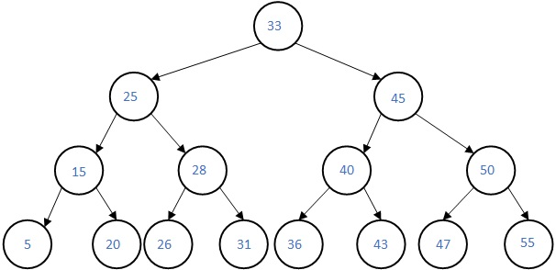
- The adversarial search. Describe its features. Write down where an adversarial search could be efficiently used (for example, games)
- Write about classification. Describe a hyperplane that divides a feature space into two classes
- Write down the sequence of numbers using the Breadth-first and Depth-first search in the binary tree

